|  |
| --- |
|  |

**“BANK MANAGEMENT SYSTEM”**

**Relational Database Management System**

**Introduction**

The "Bank Account Management System" project is a prototype for an Internet Banking Site. This site allows customers to perform basic banking transactions from their office or home using a PC or laptop. The system lets customers create accounts, deposit/withdraw cash, and view account reports. Customers can access the bank’s website to check their account details and perform transactions as needed. Internet Banking transforms the traditional banking model into a virtual one, enabling round-the-clock global banking.

The main objective of this "Bank Account Management System" is to provide a scalable and modifiable design, essential for a dynamic sector like banking. This requires a design that can be expanded and adapted, thus a modular approach was used in developing the application.

Anyone holding an account in this bank can join the Bank Account Management System by filling out a form with their personal details and account number. Banks offer a sense of security for customers' assets, and managing a bank efficiently ensures customer trust and satisfaction. Proper management also aids the administration in making decisions for future enhancements.

Managing a bank can be challenging, hence the necessity for software to streamline operations. The world is becoming increasingly digital, necessitating efficient software for bank management. All transactions are conducted online, overcoming the limitations of manual systems.

**Abstract**

The Bank Account Management System is an application designed to manage a person's bank account. This project demonstrates the functioning of a banking account system, covering essential features. The goal is to develop software to meet the financial needs of customers in a banking environment, providing various banking functionalities not available in conventional systems.

The project utilizes Java language for development. Effective management of requirements is crucial to meet customer needs, ensure compliance, and stay on schedule and within budget. Poorly defined requirements can lead to non-compliance or even harm. Proper requirements management delivers high returns on investment.

The project involves analyzing system requirements, specifying them, studying related systems, and designing the system accordingly. The system is implemented in Java, featuring an interactive and content management system, enhancing efficiency and saving transaction time.

**Aim of the Project**

The primary aim of this Internet Banking System project, developed using Java, is to provide secure and efficient online banking services. Apache Server Pages and MYSQL database are used to create this application, allowing customers to log in securely and perform various banking tasks such as money transfers and payments.

**Main Purpose**

Traditionally, banking details were recorded manually, and users had to visit the bank for transactions. This project automates banking activities, providing a real-life understanding of an Online Banking System. The system captures real-life banking activities, ensuring up-to-date information and efficiency.

**Main Goals**

1. **Motto**: Develop software to manage bank processes related to administration and customer accounts, ensuring customer satisfaction in today’s fast-paced world.
2. **Customer Satisfaction**: Provide secure, risk-free operations, maintaining customer privacy.
3. **Saving Customer Time**: Allow customers to perform transactions without visiting the bank.
4. **Protecting the Customer**: Ensure customer satisfaction by protecting their accounts and privacy.
5. **Transferring Money**: Facilitate money transfers to other banks or countries.

**Methods**

* Generate an account number.
* Account types: Savings or Current.
* Maintain/update balance.
* Open/close accounts.
* Withdraw/deposit money.

**Administrative Modules**

The project includes two main modules:

**Admin Module**:

* Admin login.
* Add/delete/update accounts.
* Withdrawal/deposit transactions.
* Account information.
* User details list.
* Active/inactive accounts.
* View transaction histories.

**User Module**:

* User login with PIN.
* New account registration.
* Funds transfer.
* View transaction statements.
* User account details.
* Change password and PIN.

**Bank Terms**

1. Customer requests are logged and effective from the time recorded at the branch.
2. Rules applicable to normal banking transactions in India apply to online transactions.
3. BAMS Bank service is discretionary and can be changed by the bank.
4. Disputes are subject to Indian jurisdiction.
5. The bank can modify services and terms, with changes notified on the site.

**Customer Obligations**

1. Maintain secrecy of Username & Password.
2. Transactions from a valid session are considered legitimate.
3. Do not attempt unauthorized access to BAMS Bank.

**Benefits of Online Banking**

Online banking offers convenience by eliminating the need to visit the bank. It allows for anytime account access, better money management, and monitoring of interest and service charges.

**Future Look**

The "Banking Online System" is ambitious and has undergone extensive research. Future enhancements may include more branches, improved customer support, and a mobile app for easy banking operations.

**Conclusion**

This project addresses banking transaction needs, providing a foundation for future enhancements. Internet banking is essential for modern banking, attracting youth and business customers. Successful implementation and execution of this Bank Management System are expected to benefit users greatly.

**References**

1. Code for Interview YouTube Channel
2. Online Bank Account Management System - Slideshare
3. Learning MYSQL JavaScript jQuery PHP HTML CSS3 - W3Schools
4. PHP and MySQL video tutorials - Free Hindi Tutorial, YouTube
5. Veneeva V. (2006) “E-Banking (Online Banking) and Its Role in Today's Society” - Ezine articles
6. JavaScript validation for empty input field - Stack Overflow
7. JavaScript form validation: Validate Password, Email, Phone Number - Webcheatsheet

**Source Code**

**MySQL WorkBench🡪**

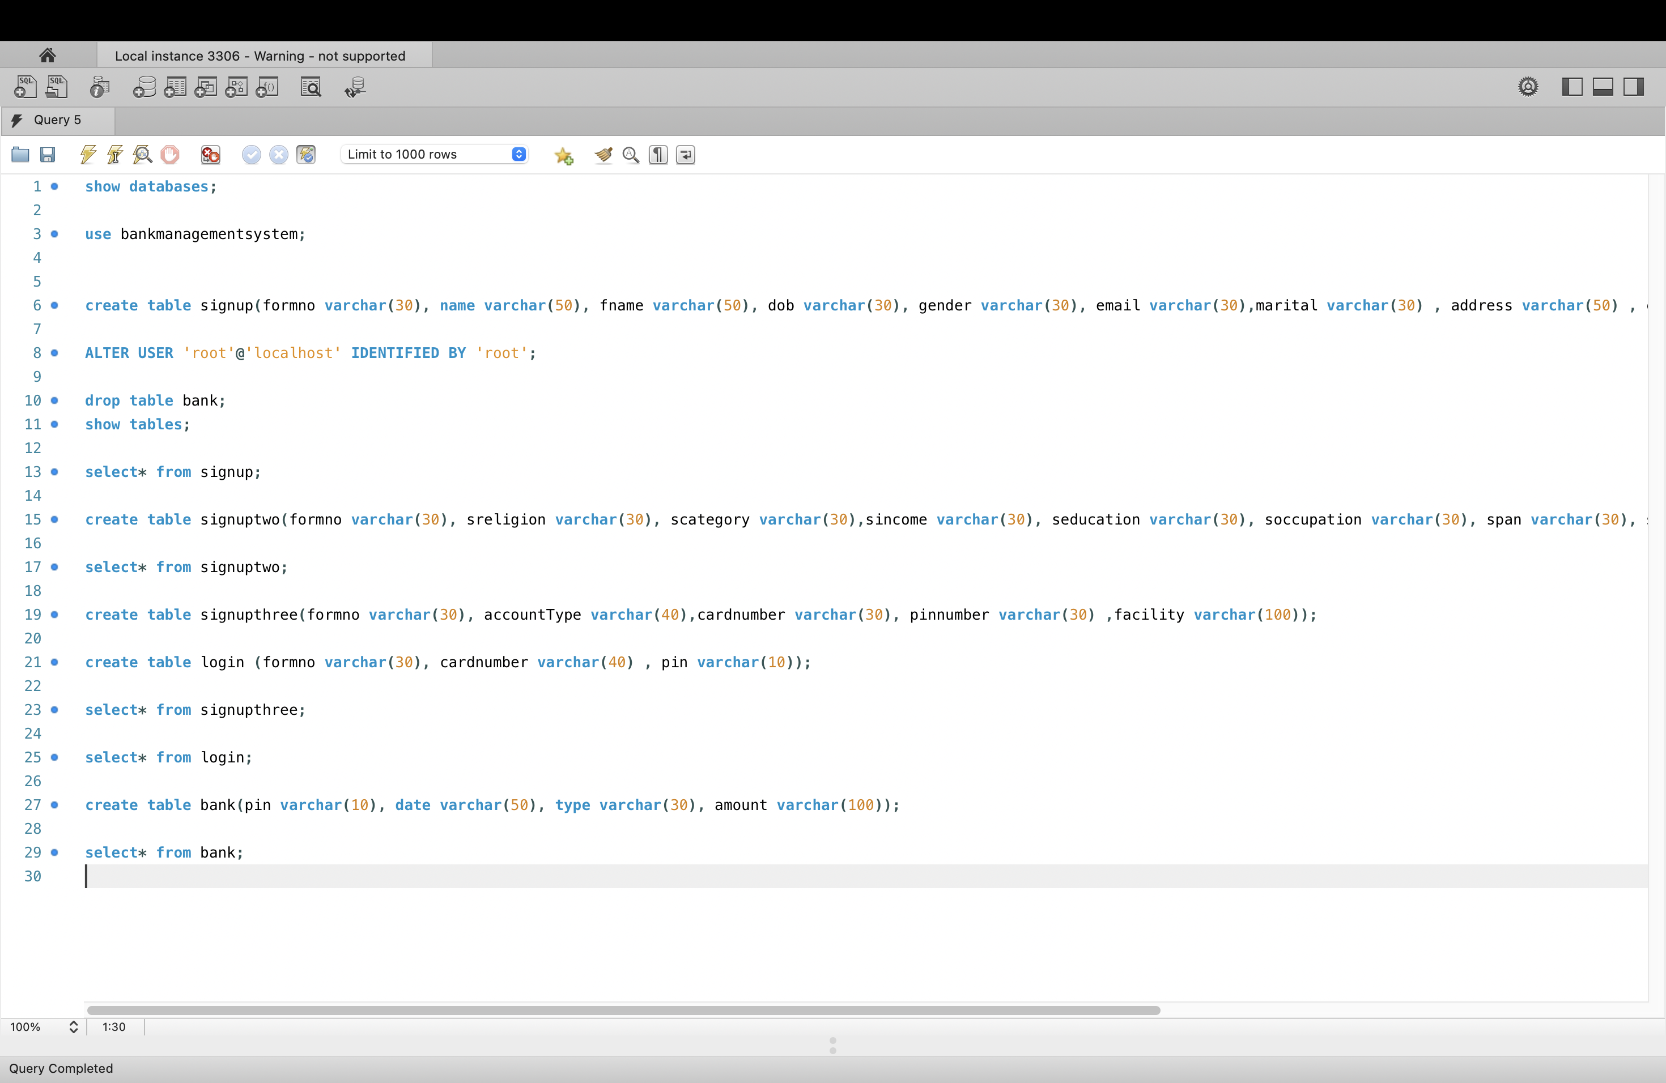

show databases;

use bankmanagementsystem;

create table signup(formno varchar(30), name varchar(50), fname varchar(50), dob varchar(30), gender varchar(30), email varchar(30),marital varchar(30) , address varchar(50) , city varchar(30) , pin varchar(30) , state varchar(30));

ALTER USER 'root'@'localhost' IDENTIFIED BY 'root';

drop table bank;

show tables;

select* from signup;

create table signuptwo(formno varchar(30), sreligion varchar(30), scategory varchar(30),sincome varchar(30), seducation varchar(30), soccupation varchar(30), span varchar(30), saadhar varchar(30), seniorcitizen varchar(30), sexistingaccount varchar(30));

select* from signuptwo;

create table signupthree(formno varchar(30), accountType varchar(40),cardnumber varchar(30), pinnumber varchar(30) ,facility varchar(100));

create table login (formno varchar(30), cardnumber varchar(40) , pin varchar(10));

select* from signupthree;

select* from login;

create table bank(pin varchar(10), date varchar(50), type varchar(30), amount varchar(100));

select* from bank;

**Transactions(MySQL) 🡪**

**Login.java**

**SignupOne.java**

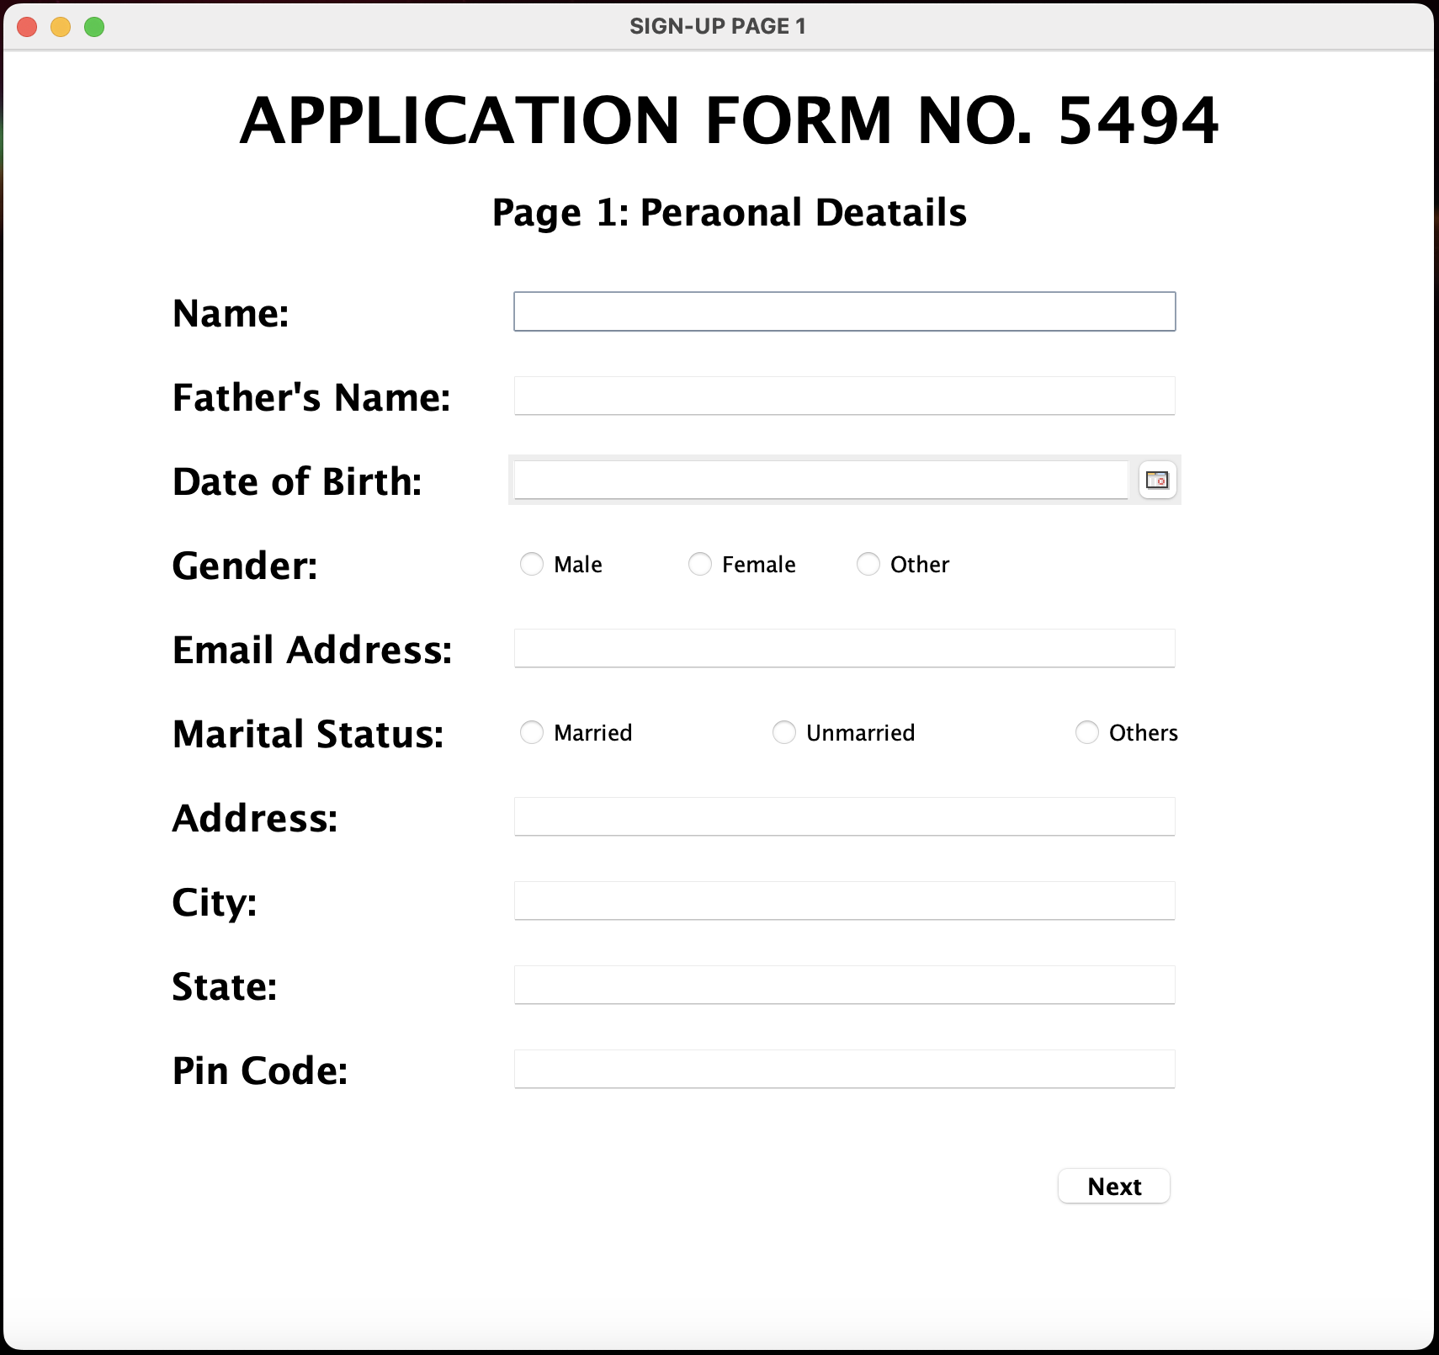

**SignupTwo.java**

**SignupThree.java**

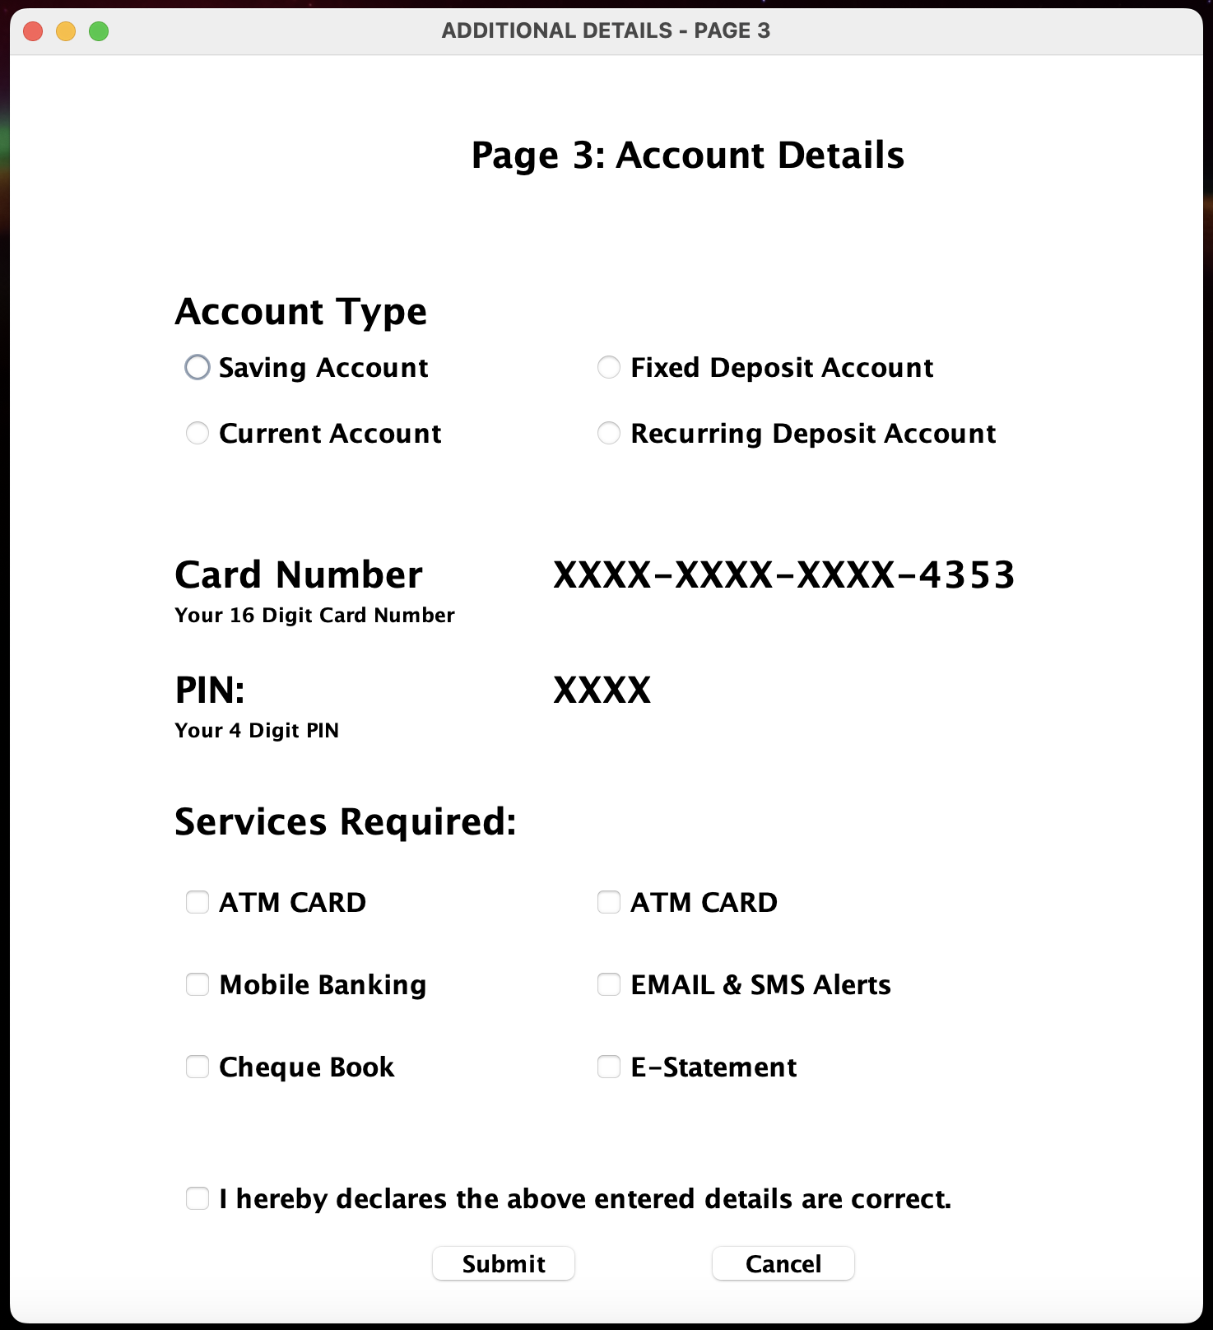

**Transactions.java**

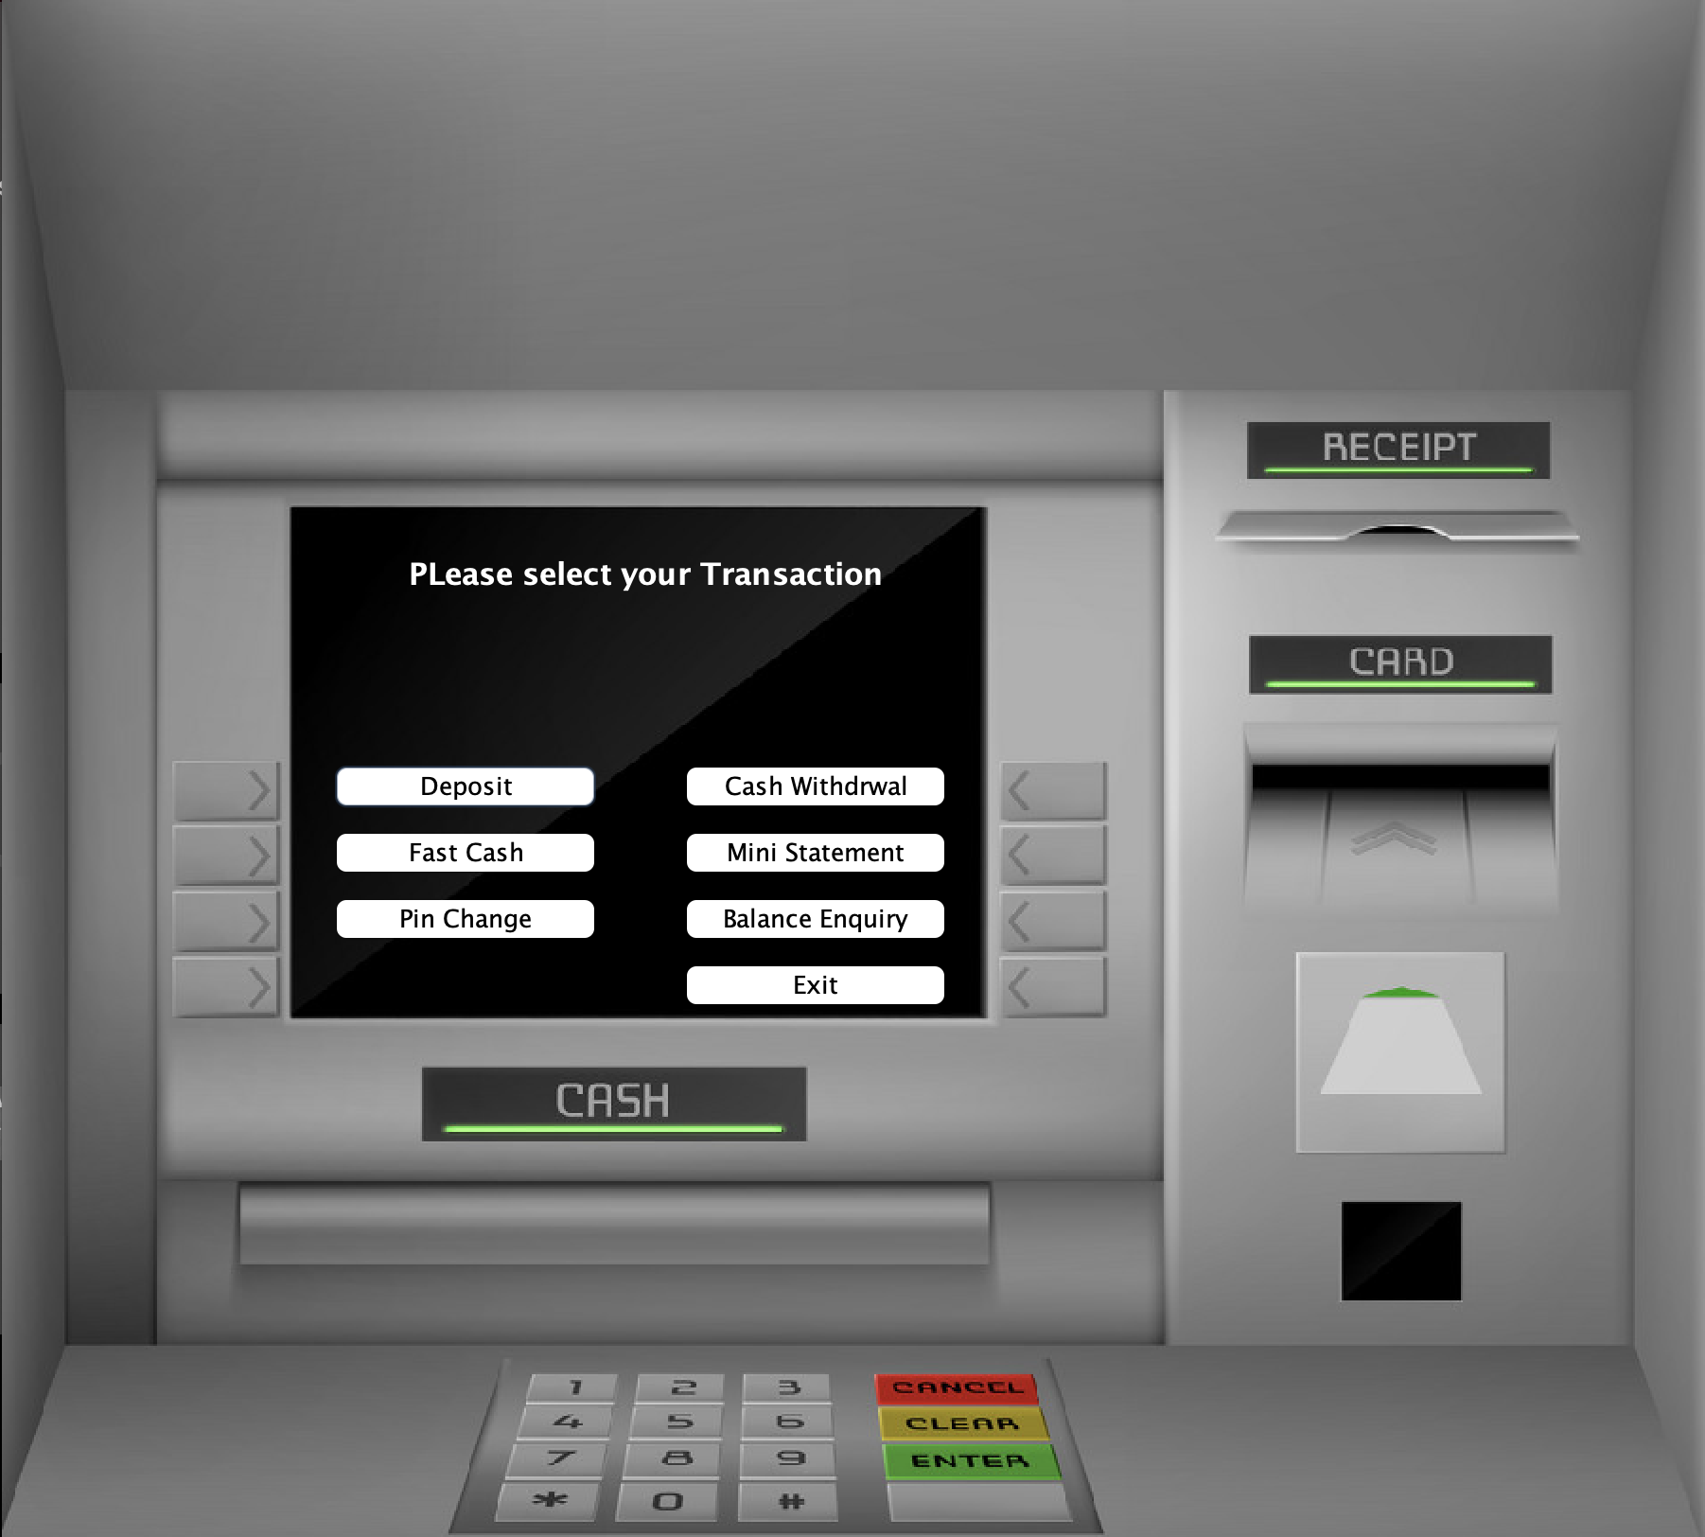

**Deposit.java**

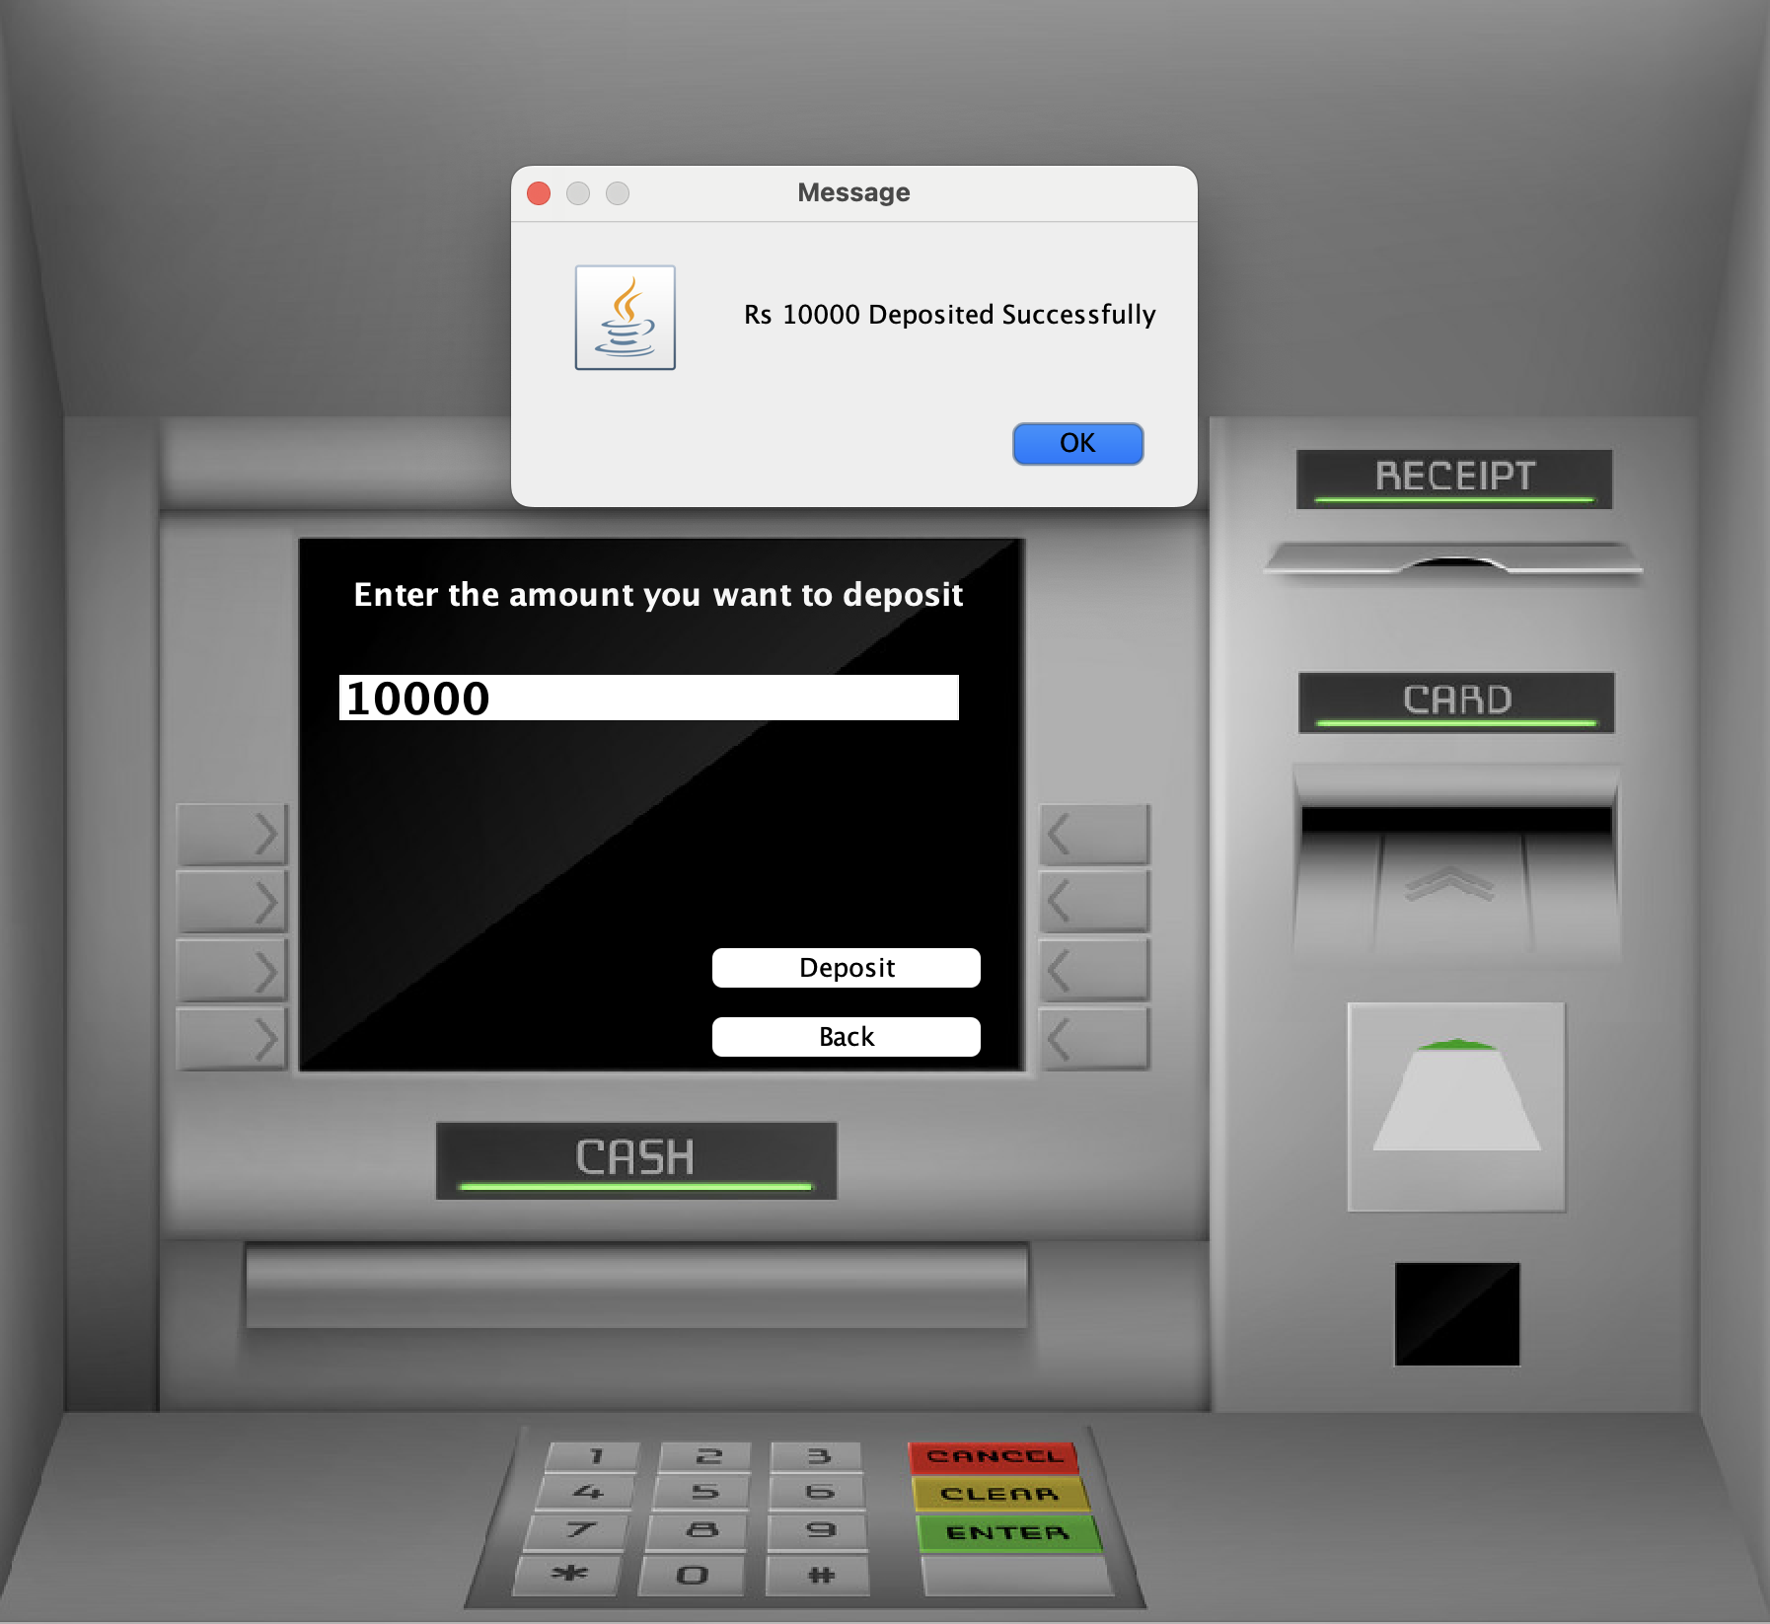

**FastCash.java**

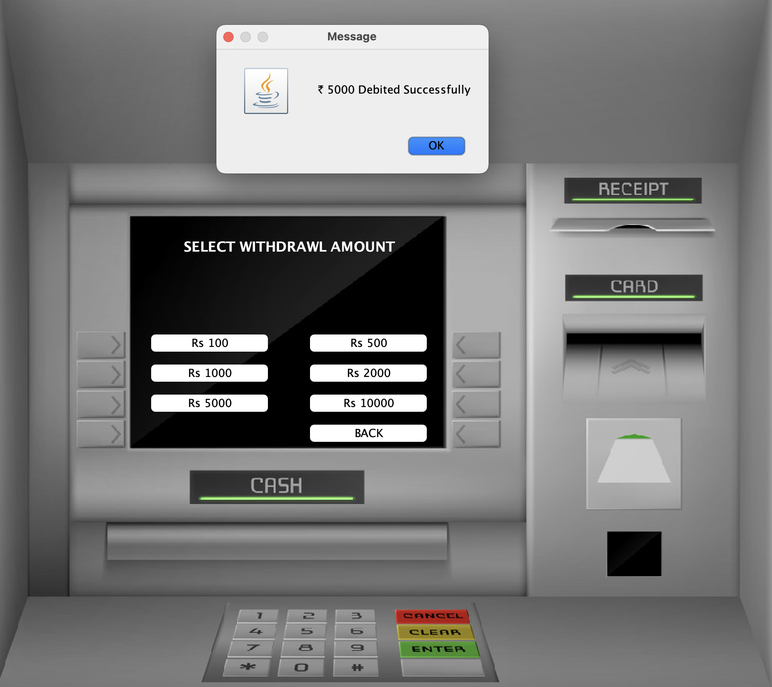

**PinChange.java**

**WithDrawl.java**

**MiniStatement.java**

**BalanceEnquiry.java**

